Official league roster - soccer
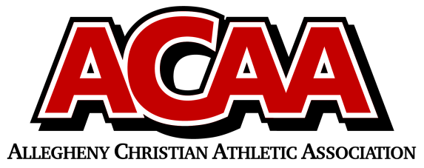
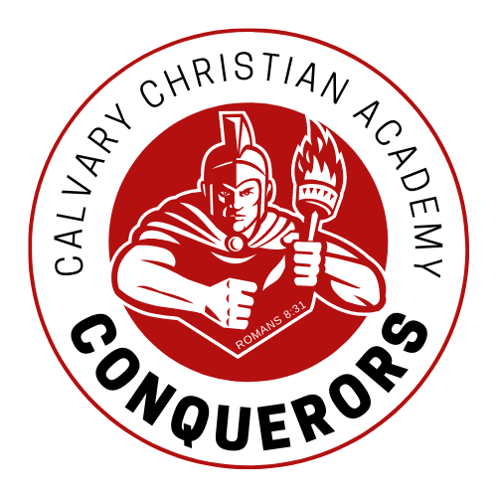
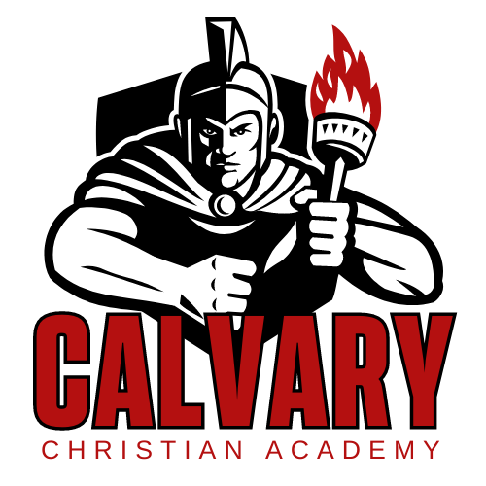

School Name: Calvary Christian Acad.
Team Colors: red/gold/white
Overall Wins ___ Losses ____ Ties ___
ACAA Wins ___ Losses ____ Ties ___ OPPONENT: __________________________
Date: _________
Number | Name | Year | Position | Height | Homeschool
9 | Nicole Ranck | Jr | defense
26 | Kelsie Taylor | Jr | defense
18 | Katie Long | Jr | midfield |  | X
27/GK1 | Olivia Mills | Soph | GK
20 | Amelia Feaster | Soph | midfield
21 | Ava Fox | Soph | midfield |  | X
24 | Reese Taylor | Soph | defense
22 | Shakia Lapp | Soph | forward
23 | Alyssa Long | Fresh | midfield
17 | Maddie McCulloch | Fresh | defense
6 | Kairi Reed | 8 | forward
15 | Ember Zeiders | 8 | midfield
12 | Harper Kanagy | 7 | forward
5 | Rosie Brantner | 7 | midfield
MGR | Mekenzy Zimmerman | 10
 | *Denotes team captain

Head Coach: Kristen haertlein
Asst. coach: Joy Martin
Scorekeeper:
Athletic director: Traci Mickey

Official ACAA League Team Roster. to be submitted to the scorer’s table before each game.

